DEPARTMENT OF KAUMARBHRITYA
Indian System of Medicine/Ayurvedic medicine has gained wide appreciation for its contribution in preventive as well as curative aspects of Health & Disease of mankind. Its well-known for the contributions to general medicine and surgery. But its contribution to newborn care, perinatal care and paediatric care are not very well known to modern world. However there are exclusive contributions in the field of Newborn and Paediatric care was well described in different texts of Ayurveda and in the first exclusive text book of Kaumarabhritya viz. Kashyapa Samhita dated 6th Century BC.
- The Department of Kaumarabhritya seeks to improve children health throughout India and beyond with its successful interventions.
- The Department also seeks to excel in academics and research

Vision
To be the leading department of Ayurvedic pediatrics in imparting knowledge, skills, caring child health and research.

Mission
- To impart comprehensive theoretical, clinical and practical knowledge to the students of Kaumarabhritya.
- To utilise, rationalise, and popularise the Ayurvedic principles of child healthcare
- Provide facilities to the graduates for the upliftment of their skills
- Conduct seminars and workshops for uplifting the knowledge of the scholars of the discipline
- To promote Ayurvedic immune boosters as a part of national immunisation programmes in children
- Conduct camps and health awareness programs with objective of imparting knowledge of basic Ayurveda among the school going children, parents and society.
The department of Kaumarabhritya has been healing the ailments and sufferings of children over the years from all around the Globe since its inception. The team includes expertise in the field with vast experience in the field.
In the academic section, the department has under graduate section for teaching and training.
Specialities of Department:
- Department is set-up with complete teaching aid for proper understanding of diagnostic and therapeutic approach through models, charts & instruments
- Hands on training are provided on Balapanchakarma during practical classes.
- Department is successfully conducting regular knowledge updating series in the form of Guest lectures and awareness talks on the eve of Autism Day, World breastfeeding week etc.
- Regular interactive sessions on health & disease aspect in Ayurveda Paediatrics are conveyed through TV & Radio programs
- Specialised well established OPD’s for Developmental, Behavioural, Infective, Nutritional Paediatrics which treat/manage diseases like Autism, Developmental delay – Cerebral Palsy, Undernutrition, Obesity, Respiratory tract infections, Neurological conditions etc.

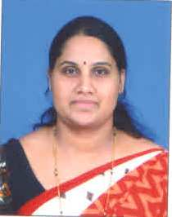 | Name: Dr.Vijayalakshmi H. Rai  Designation: H.O.D & Professor  Qualification: B. A. M. S., M. D. (AYU)  DOB: 10.07.1976  Experience: 12 yrs  DOJ: 19/12/2019  Reg No: K.A.U.P Board 15265  Teachers Code: AYKB00293
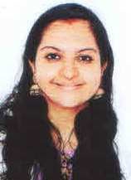 | Name:Dr.Suja K  Designation:Asst Professor  Qualification: B.A.M.S , M.D (AYU)  DOB: 26-10-1993  DOJ: 15-12-2022  Reg No. T.C.M.C : 19504

