DEPARTMENT OF ROGA NIDANA
Ayurveda is an ancient system of Medicine which is a science as well as philosophy. Hence it is known as Science of Life. It has mainly 8 Branches which covers all gambits of human life.
Diseases are the effect of many causes. These require intervention with medicine, surgery, dietary regimens or other measures in the form of counselling.
Roganidana mainly comprises of identification of a disease .The cause and the morbid change (etiology and pathogenesis) in the body is known by the study of RogaNidana.
The above can be accomplished by both RogaPariksha and RogiPariksha (Disease and patient examination).
In present day era diagnosis of a disease is done using highly sophisticated techniques and technologies. In fact these are complimentary to Ayurveda for an early and precise diagnosis. This helps the vaidya to know the diagnosis and prognosis to effectively treat the patient.
To educate the students of Ayurveda, Department of RogaNidana has made every effort by establishing a well-equipped Laboratory, museum and giving patient training in the hospital to becoming an efficient clinician.
Vision:
Skill of a vaidya is known through his ability of diagnosis of a disease.This is accomplished by the evidences of Aptopadesha (good class room teaching), Pratyaksha (Clinical training) and Anumana (Laboratory).
Roga&RogiPariksha is complete only after the Proper Knowledge and practice.
Mission:
To prepare the student of Ayurveda as a competent vaidya by providing every opportunity to improve his knowledge
This is done through good class room teaching (Aptopadesha), Laboratory (Anumana) and Clinical training (Pratyaksha).
Specialties of Department:
Department is set-up with complete teaching aid for proper understanding of diagnostic through department library, pathological specimens, models, charts & instruments
Hands on training are provided on Clinical examinations, Laboratory procedures during practical classes.

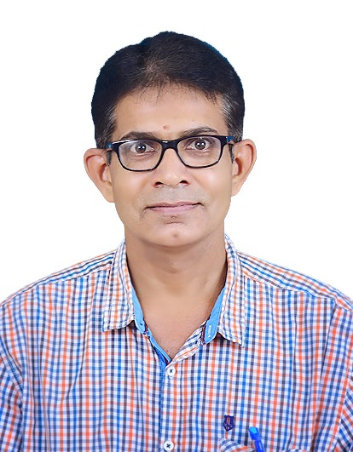 | Name:Dr. Shivarama Joshi  Designation : Professor & HOD  Qualification: BAMS, MD  DOB : 21/07/1971  DOJ: 16/01/2004  Experience :17 Years  Reg no: K.A.U.P Board 11734  Teacher code: AYKC00227
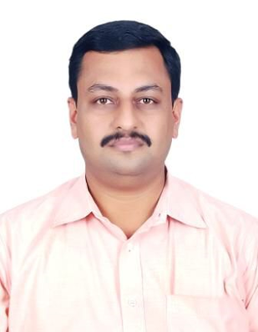 | Name: Dr.P.Subramanya  Designation : Professor  Qualification: BAMS, MD (Ayu)  DOB : 23/09/1981  DOJ: 04/05/2021  Experience : 12 years 7months  Reg no:K.A.U.P Board 17647  Teacher code: AYRN00081
 | Name: Dr.Arun Raj M.N.  Designation : Associate Professor  Qualification: BAMS, MD (Ayu)  DOB : 09/12/1990  DOJ: 11/12/2018  Experience : 5 yrs  Reg no:TCMC16027  Teacher code: AYRN00062

