DEPARTMENT OF SHAREERA RACHANA
Life science has been divided into two main branches namely ShareeraRachana (Anatomy) and ShareeraKriya (Physiology).These two provide the foundation for understanding the body parts and functions.
Anatomy is the study of structure and relationships among the structures .although anatomy was first studied by dissection of Cadavers, many other techniques now contribute for the advancement of the anatomical knowledge
Vision:
To create an excellent academic environment and to nurture competent and compassionate future Ayurvedic medical doctors by providing practical and clinical based knowledge of Rachanashareera and Anatomy.
Mission:
To make the department of anatomy well equipped with latest technologies.
To make students to understand the study of normal body structure as stated in Ayurveda Samhita as well as Modern Science.
To train future young Doctors / Professionals by teaching the basic structures of the Human body and clinical applications, which will aid them in future for careful diagnosis& proper treatment for patients.
Specialties of Department

- Complete dissection of Cadaver in a systematic manner forms the major part of the practical which will aid them to understand various systems
- To enhance the primary knowledge of human body through the department Library
- Orient various schools and college students to excel in anatomy of human body during their visit to well-equipped Anatomy Museum

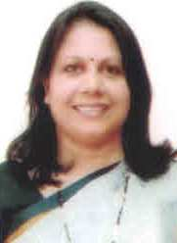 | Name: Dr.JacinthaMeena D’Souza  Designation: Professor & HOD,  Qualification: BAMS, MD (Ayu)  DOB : 13/12/1969  DOJ: 01/06/2007  Experience : 14 Years  Reg no: K.A.U.P Board 12135  Teacher code: AYRS00069
 | Name: Dr.DhananjayaAlva.M  Designation: Associate Professor,  Qualification: BAMS, MS (Ayu)  DOB : 12/04/1983  DOJ: 08/11/2011  Experience : 9 Years 11 month  Reg no: K.A.U.P Board 23317  Teacher code: AYST00126
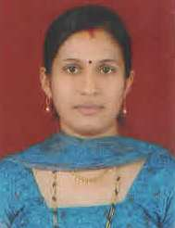 | Name : Dr. Pooja Rani  Designation :Associate Professor  Qualification: B.A.M.S , M.D (AYU)  DOB: 01-02-1986  DOJ: 02-01-2023  Experience : 7 years 11 months  Reg No. K.A.U.P Board: 24262  Teachers Code: AYRS00612
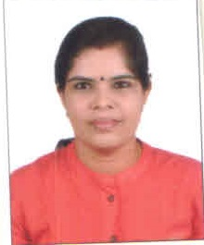 | Name : Dr. Priya Rajan  Designation : Asst. Professor  Qualification: BAMS, MD (AYU)  DOB: 17/10/1987  DOJ: 02/11/2023  Experience : 4 years  Reg No. K.A.U.P Board  Teachers Code: AYRS00016

