DEPARTMENT OF KAYACHIKITSA

The Department of Kayachikitsa has been a ready reckoner of Clinical Healthcare and Academics of Karnataka Ayurveda Medical College Hospital Mangalore.Our students undergo training with an Ayurvedic Aprroach to the treatment of various ailments.We facilitate innovative teaching and active learning for both UG and PG Students.We encourage the Students for Research Activities as this is the main pillar of the department of Kayachikitsa.We have a team of well qualified,Experienced,Enthusiatic faculty who train the students in various Communicable and Non Communicable disorders.

Vision:
To provide active learning and innovative teaching in Kayachikitsa and inculcate Research Skills for both Undergraduate Students and Post Graduate Students of Kayachikitsa.

Mission:
Preventive,Curative and Promotive Health Services to the Community in various communicable and non-communicable disorders
Help Students to inculcate Research Skills in Kayachikitsa.
High Quality Training skills in the field of Kayachikitsa

Specialties of Department:
- Extensive library with numerous books related to subject of Ayurveda and its philosophy.
- Innovation and Upgrading the department by the inculcating the students & staff to practice classical techniques with integrative teaching keeping in pace with scientific research

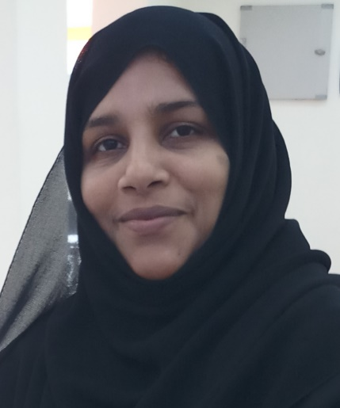 | Name: Dr.Waheeda Banu  Designation: H.O.D & Professor  Qualification:B.A.M.S.,M.D.(Ayu) Ph.D.  Additional Qualification: PGDPCG (PG Diploma in Psychological counseling and guidance), Diploma in Ayurvedic Beauty Care  DOB: 22/02/1978  Experience: 13 yrs 4 months  DOJ: 11/10/2019  Reg No: K.A.U.P Board 15242  Teachers Code: AYKC00401
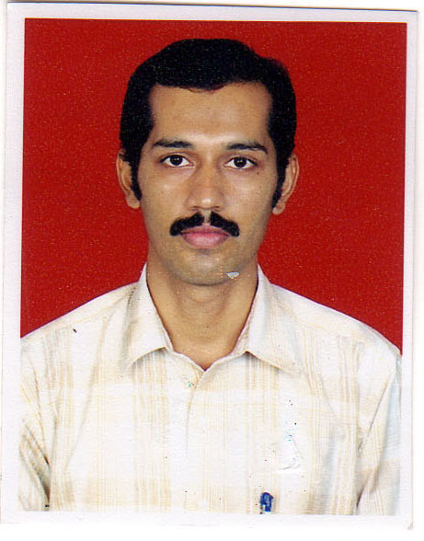 | Name: Dr K.Ravindra Bhat  Designation: Professor  Qualification:B.A.M.S.,M.D.(Mano Vigyan Avum Manasaroga)  Additional Qualification:  M.Sc (Councelling Psychotherapy)  DOB: 01.10.1978  Experience: 14yrs 9months  DOJ: 16.05.2007  Reg No: K.A.U.P Board 15214  Teachers Code: AYUKC00287
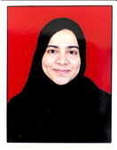 | Name: Dr. Arshiya Ali  Designation : Associate Professor  Qualification: BAMS, MD(Kayachikitsa)  DOB : 02/04/1986  DOJ: 01/08/2020  Experience : 5 years  Reg no: K.A.U.P Board 25791  Teacher code:AYKC00294
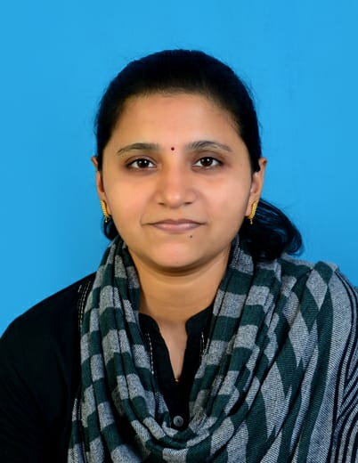 | Name: Dr.Sahana M.  Designation: Assistant Professor  Qualification:B.A.M.S.,M.D.(Ayu)  DOB: 03.09.1988  Experience: 3yrs  DOJ: 21.01.2019  Reg No: K.A.U.P Board 39356  Teachers Code: AYKC00225
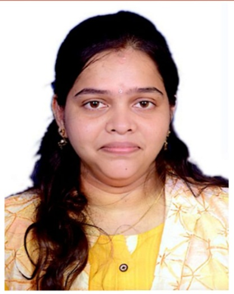 | Name: Dr .Pallavi K.S  Designation: Assistant Professor  Qualification:B.A.M.S.,M.D.(Mano Vigyan Avum Manasaroga)  DOB: 19/12/1991  Experience: 3 years  DOJ: 23/1/2019  Reg No: K.A.U.P Board 33612  Teachers Code: AYKC00207
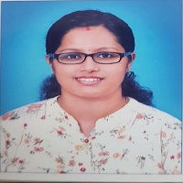 | Name: Dr .Archana K  Designation: Assistant Professor  Qualification:B.A.M.S.,M.D.(Ayu)  DOB: 26.03.1989  Experience: 3years  DOJ: 01.04.2023  Reg No: K.A.U.P Board 32287  Teachers Code: AYKC03637

