DEPARTMENT OF MOULIKA SIDDANTA

Introduction:
The department deals with the roots of guiding principles of Ayurveda. In here the purpose of the science of Ayurveda which is the betterment of health is attained by undertaking extensive training of the Language of Sanskrit and regular Samhitadhyayana.
We teach about the scriptures of Ayurveda like Charaka Samhita,Sushrutha Samhita and Ashtanga Hrudaya. These Shastras which talk about the proper understanding of physical, mental,social and spiritual wellbeing. There by exposing the students to Ayurveda and make them understand the science.
Vision
Make the aspiring students of Ayurveda well versed in the scriptures of Ayurveda and help them to implement them.
Mission
To educate the purpose of our science of medicine.
To train the students in the learning of Ayurveda with proper and clear understanding of the science.
Make the student adept and experienced in Ayurveda and its methods.

Specialities of Deparment:
Extensive library with numerous books related to subject of Ayurveda and its philosophy.
Exclusive models of theoretical concepts for easy understanding.

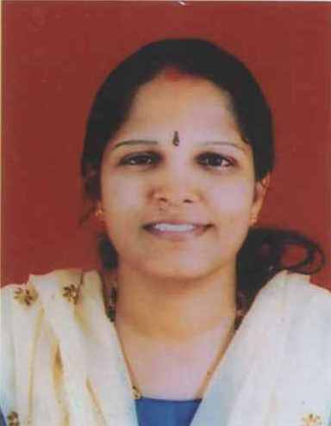 | Name: Dr. Suchitra P.S.  Designation: Professor & HOD  Qualification: BAMS, MD (Ayu)  Additional Qualification: M.A.Sanskrit  DOB : 04/05/1976  DOJ: 28/06/2004  Experience : 17 Years  Reg no: K.A.U.P Board 12409  Teacher code: AYSS00202
 | Name: Shri.Janardana Bhat  Designation: Assistant Professor  Qualification: B.Ed, M.A (Sanskrit)  DOB : 06/06/1964  DOJ: 01/09/2002  Experience : 19 Years  Reg no: M.A.208, B.Ed 200763  Teacher code: AYSN00098
 | Name: Dr Mithun R G  Designation: Associate Professor  Qualification: BAMS, MD (Ayu)  DOB : 30-11-1990  DOJ: 01-01-2021  Experience : 5 yrs  Reg no: TCMC 14849  Teacher code: AYSS00098
 | Name: : Dr Ashwini A  Designation: Assistant Professor  Qualification: BAMS, MD (Ayu) NIA Jaipur  DOB : 17/06/1991  DOJ: 30/12/2019  Experience : 2yrs, 1month  Reg no: K.A.U.P Board 32591  Teacher code: AYSS01122

DEPARTMENT OF RESEARCH METHODOLOGY & MEDICAL STATISTICS
 | Name: Miss. Vijetha  Designation: Statistician  Qualification: M.com  DOB: 16.05.1997  DOJ: 08//02/2021  Experience: 1 year  Teacher code: Part time Staff

