DEPARTMENT OF PRASUTI TANTRA AND STRI ROGA

Introduction
- Prasuti Tantra Evam Stri Roga is an important branch of Ayurveda mainly dealing with delivery of a child (Prasuti Tantra /Obstetrics) and diseases pertaining to female reproductive system (Stri Roga / Gynaecology). It focuses on a complete care of a woman from menarche to menopause and beyond. It not only advocates treatment for various disorders in women but also suggests various regimens at each important transitional phase like Rithumathi charya during the menstrual phase, garbha samskara to achieve healthy pregnancy garbhini paricharyas during pregnancy, soothika paricharya after delivery. It emphasises the importance of women’s health as she is the person who is responsible for the next generation.

Vision
- To empower each & every student and to provide excellent doctors to the society, who can handle any ailments related to health of women.

Mission
- To give rise to efficient graduates of Ayurveda through innovative, creative, and interesting programmes, who can excel in patient care.
- To utilize the techniques of female health care and to achieve a healthy baby through quality care and training.
- To impart the knowledge of health of women of all ages and to conduct quality research on community needs.

Specialities
- Department has well established OPD, IPD, minor and major operation theatre to provide pre-conceptional care, Antenatal care, post-natal care & to treat all Gynaecological issues.
- It is well established with Ayurveda teaching hospital for infusing knowledge to students.
- Imparting knowledge through Classroom Teaching, Audio Visual learning, Group discussions, Quiz, class seminars, CMEs, Case-demonstrations etc
- Efficient learned teaching faculty
- Good collection of books in library concern with subject.
- Regularly conducting educative programmes to develop communication skills.
- Regularly conducting public awareness programmes on women’s health.
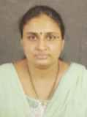 | Name: Dr.Asha K.  Designation: Professor & HOD  Qualification: BAMS, MS (Ayu)  DOB : 03/07/1976  DOJ: 23/10/2018  Experience : 14 Years  Reg no: K.A.U.P Board 13196  Teacher code: AYPS00085
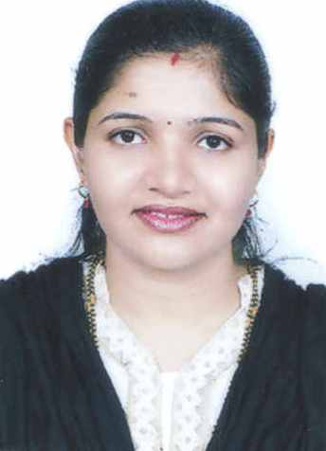 | Name: Dr.Vani  Designation: Associate Professor,  Qualification: BAMS, MS (Ayu)  DOB : 07/03/1987  DOJ: 03/03/2014  Experience : 07 Years  Reg no: K.A.U.P Board 26376  Teacher code: AYPS00181
 | Name: Dr.Megha Udai  Designation: Assistant Professor,  Qualification: BAMS, MS (Ayu)  DOB : 17/03/1990  DOJ: 03/09/2021  Experience : 04Years, 02 months  Reg no: TCMC-13960  Teacher code: AYPS00010
 | Name: Dr.Sanju John  Designation: Assistant Professor,  Qualification: BAMS, MS (Ayu)  DOB : 07/11/1990  DOJ: 01/01/2020  Experience : 01 Years, 10 month  Reg no: TCMC –15026  Teacher code: AYST01568
 | Name: Dr.Neethu Dev  Designation: Assistant Professor,  Qualification: BAMS, MS (Shalya Tantra)  DOB : 16/11/1990  DOJ: 07/12/2020  Experience : 1 year,02 Months  Reg no: TCMC –16403  Teacher code: AYST01836

