DEPARTMENT OF RASASHASTRA EVAM BHAISHAJYA KALPANA
Introduction
The subject of Rasashastra and Bhaishajya Kalpana forms the core foundation of Ashtanga Ayurveda. It has the gleanings of both the Shaiva and Brahma Sampradaya. Rasashastra deals mainly with medicines being prepared out of metals, minerals, poisons and animal products, whereas Bhaishajya Kalpana is a broader terminology which deals with therapeutics of plant origins.
The history of these subjects stands right from Satya yuga (Treta yuga) scattered references can be found in the Vedas.
Karnataka Ayurveda Medical College which was established in 1994 has all the requirements for the Rasa Shastra Evam Bhaishajya Kalpana Department for Postgraduate sections.
Vision
- “Siddhe rase karishyami nirdharidryam idam jagat”
Mission
- The Department of Rasashastra and Bhaishajya Kalpana trains the students with Ayurvedic Pharmaceutical sciences especially the concepts of Rasashastra and Bhaishajya in second year.
- Department deals with identification, collection of herbs and minerals and preparation of various dosage forms like Avaleha, Arishta, Asava, Churna, Vati/gutikas, Bhasmas, Pottalis and Rasoushadhis.
- The Department is fully equipped with various yantra, instruments, models, charts, specimens etc.(photo).
- All essential practicals are carried out in Ug/Pg Laboratory where students learn preparation of various Ayurvedic medicines as Churna, vati, guggulu, Asavarishta, Sneha Kalpa, Kshara, Lavana, Loha kalpa, Avaleha, Kupipakwa Rasayana, Pottalis.
- Quality testing laboratory provides various modern analytical instruments and all research oriented practicals. Raw drug store contains the required dry raw drug materials. Yantras (Khalwa, Dola, Valuka, Pitara, Arka, Ulukala), Putas, Kupipakwa batti, Electric Muffle Furnace, Mixer, Grinder, Containers and miscellaneous equipments and instruments are available in this laboratory.
- Students get to know Shodana, Marana. Grahya agrahyata, identification and sources, processing techniques, posology, quality control, standardization and GMP, knowledge of Drugs and Cosmetic Act and Rules 1945.
Speciality of the Department
- To trains Under graduate Post Graduate Ayurvedic Medical students about Ayurvedic pharmaceutics in fully equipped Rasashastra and Bhaishajya Kalpana teaching laboratory.
- To have a fully equipped Rasashastra museum with Charts, Yantras, Specimens, Instruments.
- Tutorial room with full-fledged Audio visual units.
- Departmental library
- QC Testing laboratory with all modern equipments and instruments.
- Central QC unit.

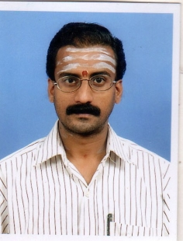 | Name: Dr.Harihara Prasad Rao  Designation : Professor & HOD  Qualification: BAMS, MD(Ayu)  DOB : 09.01.1975  DOJ: 16.05.2007  Experience : 14 Years  Reg no: K.A.U.P Board 13499  Teacher code: AYRB00133
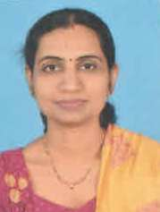 | Name: Dr.Rachana C  Designation : Professor  Qualification: BAMS, MD (Ayu)  DOB : 11.01.1981  DOJ: 01.12.2008  Experience : 13 Years 2 months  Reg no: K.A.U.P Board 17157  Teacher code: AYRB00127
 | Name: Dr.Vani B.  Designation : Associate Professor  Qualification: BAMS, MD (Ayu)  DOB : 30/05/1985  DOJ: 15/05/2013  Experience : 8Years 8 months  Reg no: K.A.U.P Board 24496  Teacher code: AYRB00126
 | Name: Dr.Akshatha Das A.V.  Designation : Assistant Professor  Qualification: BAMS, MD (Ayu)  DOB : 18/02/1990  DOJ: 29/07/2019  Experience : 4Years 1 months  Reg no: K.A.U.P Board 30964  Teacher code: AYRB01391
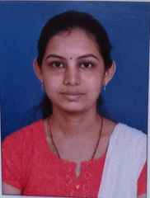 | Name: Dr.Shruthi B.Naik  Designation : Assistant Professor  Qualification: BAMS, MD (Ayu)  DOB : 21/07/1991  DOJ: 23/03/2020  Experience : 1Years 10 months  Reg no: K.A.U.P Board 33388  Teacher code: AYRB01472

