DEPARTMENT OF SHALAKYA TANTRA
Introduction:
Shalakyatantra is a branch of Ayurveda which deals with ailments related to Eye, ENT, Oro-Dental, Head and Neck.These being the vital sensory organs,there is dire need to protect and preserve the health of these organs, hence known as ‘Uttamangachikitsatantra’.More than 200 clinical conditions & their management that includes several drug formulations and therapeutic procedures are vividly explained in Shalakyatantra.This science uses a lots of ‘Shalaka’ which means probe which justifies the name Shalakyatantra and specialists in this branch are called ‘Shalakis’.
Vision:
- To establish best management centre for diseases of Eye, Ear, Oral cavity, Nose, head and neck in both preventive & curative aspect.
Mission:
- Our efforts are dedicated to create confidence among students to deal every case of Shalakyatantrathrough classical Ayurveda approach and modern diagnostic view.
- Our endeavour is to provide all possible support to promote research orientation in unexplored areas of Ayurveda ophthalmology & ENT.
- Our strength is directed to create competent professionals and service to mankind.

Specialities of Department:
- Set with complete teaching aid as a part of structural & functional understanding,diagnostic and therapeutic approach through models, charts&instruments along with departmental museum.
- Hands on training on kriyakalpas,sthanikaupakrama,parasurgical procedures during practical classes.
- Department is successfully conducting Guest lectures and awareness talks on the eve of sight day, deaf day etc.
- Awareness about sense organs and treatment options in Ayurveda are conveyed through TV & Radio programs

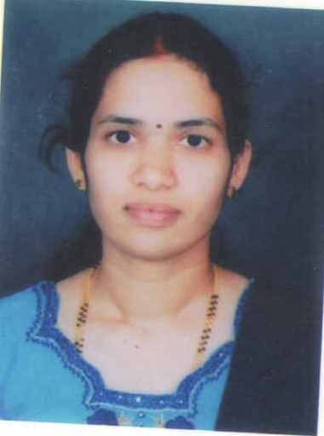 | Name: Dr.VeenaVinayak  Designation : Professor & HOD  Qualification: BAMS, MS(Shalakya Tantra)  DOB : 23/12/1980  DOJ: 03/08/2009  Experience : 12yrs  Reg no: K.A.U.P Board 17155  Teacher code: AYSK00060
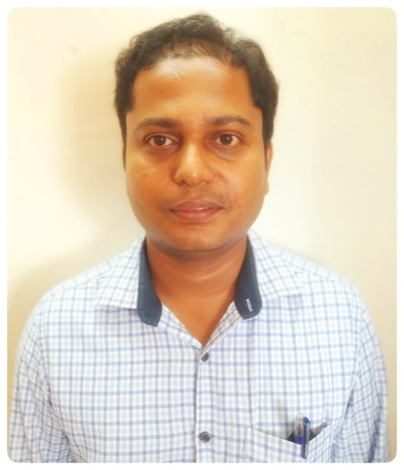 | Name: Dr.Santhosha Kumar  Designation : Associate Professor  Qualification: BAMS, MS(Shalakya Tantra)  DOB : 01/05/1986  DOJ: 01/01/2013  Experience : 9yrs 1month  Reg no: K.A.U.P Board 24606  Teacher code: AYSK00063
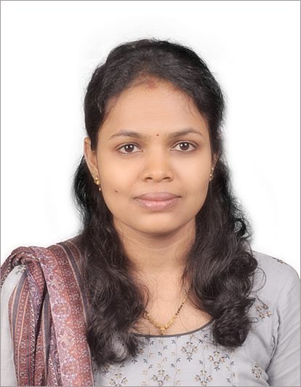 | Name: Dr.SwatiS.Suvarna  Designation : Associate Professor  Qualification: BAMS, MS(Shalakya Tantra)  DOB : 25/01/1992  DOJ: 10/12/2018  Experience : 5yrs  Reg no: K.A.U.P Board 32753  Teacher code: AYSK00062
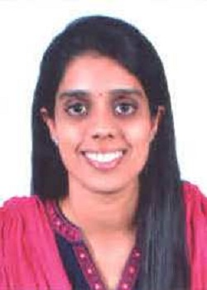 | Name :Dr. Deena Manju  Designation :Asst Professor  Qualification: B.A.M.S , M.D (AYU)  DOB: 29-10-1990  DOJ: 02-12-2022  Experience : 2 years 11 months  Reg No. K.A.U.P Board: 31969  Teachers Code: AYSK00669

