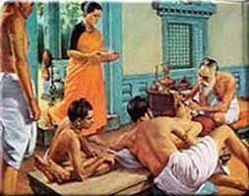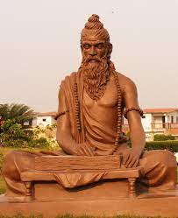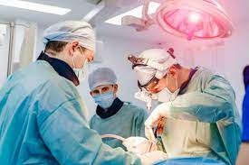

**DEPARTMENT OF SHALYA TANTRA**

**Introduction**

Shalya means that which creates pain or agony to the body or mind and Shalyatantra is the branch which deals with the techniques by which this cause (Shalya) is removed. Thus ShalyaChikitsathe branch of Ayurveda medicine that uses Surgical techniques  traces its origin to the most established treatise on Ayurveda, SusrutaSamhita.Dealing with Surgical and Para surgical procedures in abundance ,AcharyaSushruta is considered to be the Father of Surgery, the Pioneer in Plastic Surgery a milestone in the field of Surgery. Over the years it has made substantial contributions in the field of Ano-Rectal Diseases, Wound Management, Urinary Disorders and Fracture Healing. Facilities  includes ancient surgical procedures and clinical applications of various treatment modalities, successful treatment for Piles and Fistula as per Ayurvedic methodology, treatment of chronic diseases with blood-letting through Leeches and practical training of surgical procedures on patients at well-equipped operation theatre and procedure room.

## Vision:

* Hand to Hand Surgical training.
* Develop basic skills to maintain surgical competence.
* Team work to give the best to patient care.
* Updating the surgical knowledge by exposing them to the modern surgical techniques.
* Surgical care delivered to even the economically backward or underprivileged society .
* Produce skilled Surgeon to serve humanity
* Establish Shalyatantra in a scientific manner in view of modern scientific surgical knowledge
* Establish Agnikarma procedure to manage pain and establish Sushruta Shat kriya Kala and ShastiUpakrama in management of Diseases

**Mission**

Effective management of surgical disorders by the principles laid by AcharyaSushruta

Practical application of para surgical procedures, Shastiupkrama in managing Surgical disorders

Innovation and Upgrading the department by the inculating the students & staff to practice classical techniques with integrative teaching keeping in pace with scientific research

Theoretical as well as practical teaching, training and guidance in the ShalyaTantra subject are provided to PG Scholars. PG Scholars are provided with innovative ideas and research activities to develop themselves in the surgical skills & subject

**Specialities of Department:**

Well-equipped Library Departmental with Modern and Ayurvedic texts to fullfill the knowledge for students as well as staff

Seminar and PG classroom for rendering the knowledge by consultants and Experts in the field with the help of Seminars and PPT projectors

Museum to assign students in various Innovative ideas and Research projects

|  |  |
| --- | --- |
|  | Name: Dr.Elizabeth John  Designation : Professor & HOD  Qualification: BAMS, MS (Ayu), Ph.D  DOB : 21/02/1967  DOJ: 02/07/2007  Experience : 26yrs  Reg no: K.A.U.P. Board 45  Teacher code: AYST01562 |
| F:\New folder (11)\Shalya\IMG-20211017-WA0006.jpg | Name: Dr Udaya D.K.  Designation : Professor /Medical Superintendent  Qualification: BAMS, MS (Ayu)  DOB : 24/03/1963  DOJ: 01/09/2002  Experience : 19yrs  Reg no: K.A.U.P. Board 9806  Teacher code: AYST00119 |
| Dr | Name: Dr. Abhinethri Hegde  Designation : Professor  Qualification: BAMS, MS (Ayu)  DOB : 13/05/1980  DOJ: 18/09/2023  Experience 13 Years :  Reg no: 15719  Teacher code: AYST01364 |
| F:\New folder (11)\Shalya\DR MEERA K BABY.jpg | Name: Dr.MeeraK.Baby  Designation : Assistant Professor  Qualification: BAMS, MS (Ayu)  DOB : 23/12/1992  DOJ: 01/12/2020  Experience : 1year,1 Months  Reg no: TCMC 17322  Teacher code: AYST01830 |
| Photo | Name: Dr. Vidhya N  Designation : Asst. Professor  Qualification: BAMS, MS (Ayu)  DOB : 27/06/1992  DOJ: 01/09/2023  Experience : 5months  Reg no: 17404  Teacher code: AYST02313 |