DEPARTMENT OF SHAREERA KRIYA
Introduction:
KriyaShareera is a subject that comes under the core of Ayurveda as it deals with the basic principles of physiology in Ayurveda. It includes the study of fundamental theorems of Ayurveda like GunaSiddhantra, TridoshaSiddhanta, PanchamahabhootaSiddhanta, Samanya -VisheshaSiddhanta, Loko-PurushaSaamya etc. Apart from these, it also includes the study of other physiological aspects of Ayurveda and even the contemporary western physiological aspects. To make students updated with the basic concepts of practical physiology, Hematological and urological experiments also have been included in the curriculum of this subject.
ShareeraKriya lab has been set-up with all the basic infrastructures meeting the recommendations of National commission.
Vision:
The vision of the department is to be the highly intensive academic department in the disciples of Ayurveda Physiology in India.
Mission:
- To carry out quality academic activities
- Evidence based teaching having primary evidences from Ayurveda text books.
- To continue innovation and excellence in teaching
- To teach in such a way that would help translate text books to practice
Specialities of Department:
- Department Museum is also well maintained to boost up the academic activities of the department. Department is provided with department library and a computer.

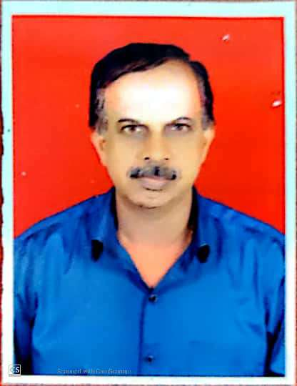 | Name: Dr.N.IshwaraBhat  Designation: Professor & HOD,  Qualification: BAMS  DOB : 23/12/1960  DOJ: 01/09/2017  Experience : 34 yrs  Reg no: K.A.U.P Board 9020  Teacher code: AYXX00140
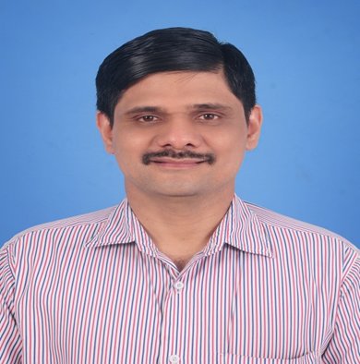 | Name: Dr.Ravikiran M.G.  Designation : Professor  Qualification: BAMS, MD (Ayu)  DOB : 10/07/1971  DOJ: 02/11/2002  Experience : 19 Years  Reg no: K.A.U.P Board 11036  Teacher code: AYKC00212
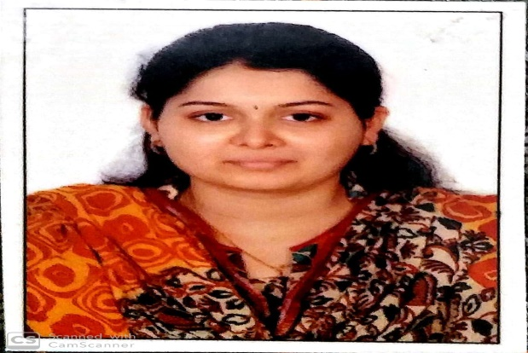 | Name: Dr.Shruthi N.Bhat  Designation: Associate Professor  Qualification: BAMS, MD (Ayu)  DOB : 05/05/1992  DOJ: 10/12/2018.  Experience : 5 years  Reg no: K.A.U.P Board 33385  Teacher code: AYKS00052
 | Name: Dr.Krithika U.Pai  Designation: Assistant Professor  Qualification: BAMS, MD (Ayu)  DOB : 08/11/1994  Department : Department of ShareeraKriya  DOJ: 01/01/2022  Experience : 1month  Reg no: K.A.U.P Board 38465A  Teacher code: AYKS00976

