DEPARTMENT OF DRAVYAGUNA VIJNANA
Introduction:
…………………………जगत्येवमनौषधम्|
नकिञ्चिद्विद्यतेद्रव्यंवशान्नानार्थयोगयोः|| (Astangahrudaya, Sutra, 9/10)

Ayurveda believes there are no plants in this universe which are devoid of medicinal properties, but one should know the proper usage of plants. Plants affect different facets of life such as cultural, economic, medicinal and spiritual. Since time immemorial plants have been extensively used by man for maintenance of health and for treatment of illness. It is interesting to observe that the detailed knowledge about plants is based on a sophisticated indigenous branch of Ayurveda called Dravyaguna. One can utilize dravyas judiciously for treatment only when one is diligent with the knowledge of the drugs. And for this, knowledge of Dravyaguna is equally important.
Our Dravyaguna department imparts applied knowledge to the students through live demonstration of medicinal plants through audio-visual classes & Survey. The department also includes Pharmacognosy, Pharmacology & Pharmaceutics. Department has started post- graduation course in the year 2014 with a vision to foster a designed environment to achieve recognition and Excellency in research & development.
It has an herbal garden ‘Dhanwantharivana’ consisting of varied species of plants used to train scholars. The herbs of the garden are used to prepare fresh medicine and cater to the in- patient needs of the hospital. It also has a full-fledged drug testing laboratory. The museum of the department enriches the knowledge of medicinal plants and its uses.
Vision
- To impart quality graduate and post graduate training in the field of Dravyagunavijnana by equipping the scholars to meet the global challenges in Health care.
Mission
- Creating awareness on the importance of medicinal plants within the society.
- To envision, organize and conduct research on folklore drugs, revalidate classical drugs and to give impetus to single drug therapy.
- Steps to conserve endangered medicinal plant species, which are rare & under the threat of extinction.

Specialties of Department
- To establish a Centre of Excellence that provides a quality and value-based teaching and training to Undergraduates & Postgraduates
- Ayurveda Diploma Course – As per STED council norms
- Department Library: Library is provided with good collection of books pertaining to Dravyaguna-Vijnana, Botany, Pharmacology, Pharmacognosy and other allied fields.
- Herbal Garden: Well-maintained Herbal garden ‘Dhanwantharivana’ has more than 328 species of medicinal plants including rare species like Ashoka, Hijjala, Syonaka, Iswari, Karpoora, Rudraksha, Patranga, Saptachakra, Jeevanti, Jyothishmati, Laksmanaphala etc. The garden also has a demonstration room & a greenhouse. In the college campus potted plants are maintained to help in academics. The department organizes field surveys to nearby biodiversity floras like Udupi, Shobavana, Pilikula, Thannirbhavi.
- DG Museum - The museum consists of 343 dry specimens, 152 wet specimens, 150 laminated Colour Plant Photo charts, 40 charts & more than 200 herbariums for display.
- Laboratory– Well establishedDravyagunaPharmacognosy Lab is spacious with all needy equipment’s like, microscopes, reagents, glass wares, instuments etc. In addition, the students are exposed to different kinds of Pharmacognostic studies & analytical tests as needed by research protocols.
- Awareness programme – Department is yearly conducting awareness programmes on conservation and cultivation of medicinal plants by conducting Vanamahotsava, Environmental Day. For general public Home remedies (Mannemaddu) programme, AtiamavasyaKashaya distribution is conducted. Departmental faculty actively participates in lectures, webinars, TV shows regarding awareness of medicinal plants.
- Research projects – We are carrying out various research projects for the betterment of the society.

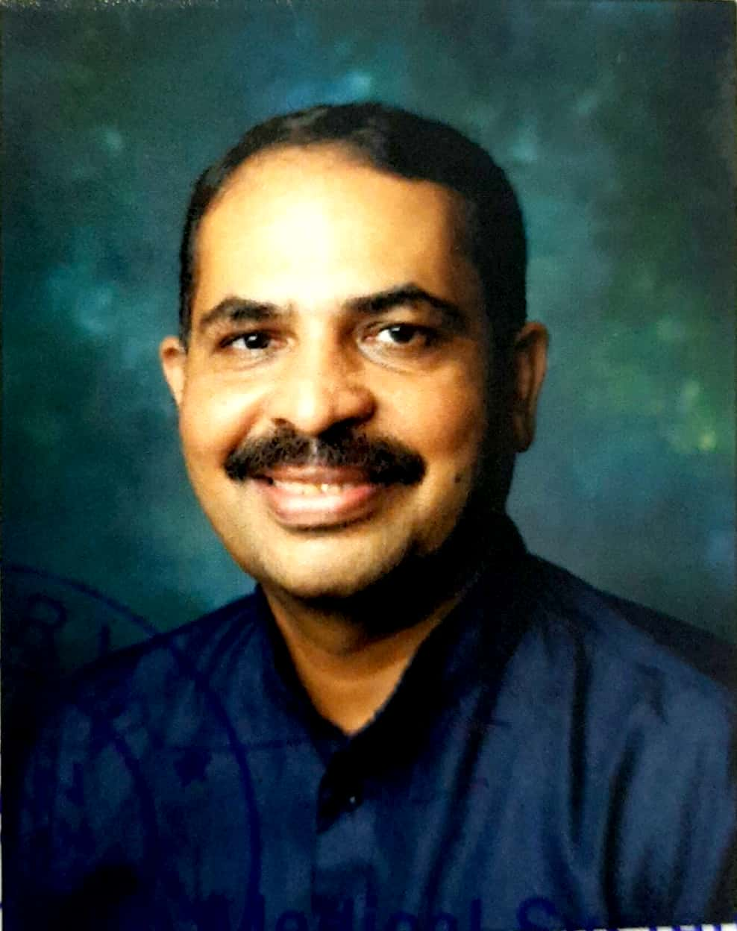 | Name: Vd Ravi Rao S  Designation: Principal/ Professor  Qualification: MD(GAU), PhD(ITRA).Department: Dravyaguna  DOB: 23/04/1975  Experience: 19 years, 6months.  DOJ: 04/06/2021  Reg No: K.A.U.P Board 11980  Teachers Code: AYDG00094
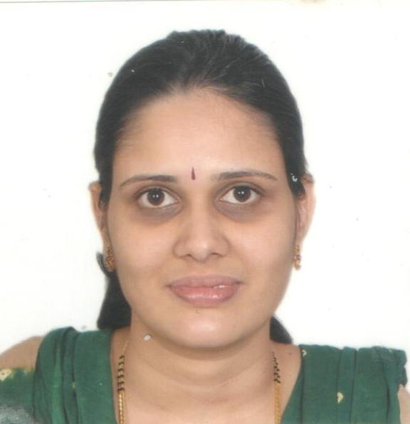 | Name: Dr.SwapnaBhat  Designation: H.O.D& Professor  Qualification: B. A. M. S., M. D. (AYU)  DOB: 14-05-1980  Experience: 15 year 03months  DOJ: 02-11-2006  Reg No: K.A.U.P Board 15336  Teachers Code:AYDG00162
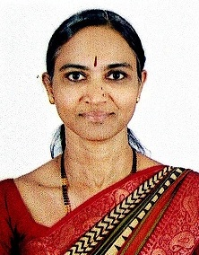 | Name: Dr.Sridevi Joshi  Designation: Professor  Qualification: B. A. M. S., M. D. (AYU)  DOB: 08-02-1967  Experience: 15 years 2months  DOJ: 02.12.2020  Reg No: K.A.U.P Board 32790  Teachers Code: AYDG00498
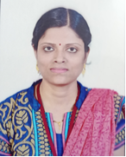 | Name: Dr.SrijayaV.Prabhu  Designation: Assistant Professor  Qualification: B. A. M. S., M. D. (AYU)  DOB: 20-05-1985  Experience: 4 years 1 months  DOJ: 05-01-2018  RegNo: K.A.U.P Board 39154  Teachers Code: AYDG00124
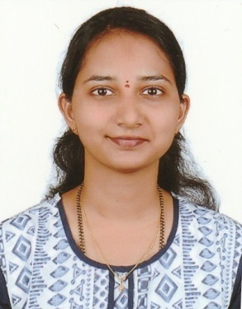 | Name: Dr.Niyathi  Designation: Assistant Professor  Qualification: B. A. M. S., M. D. (AYU)  DOB: 22-05-1992  Experience: 2 year 2months  DOJ: 14-12-2019  Reg No: K.A.U.P Board 34433  Teachers Code: AYDG01160

